**­**

**Design Document for:**

# Parker & Holt

All work Copyright © (2009) by Matt King & Greg King

Written by Matt King & Greg King

Version # 1.06

4/13/2010Table of Contents

Table of Contents

Parker & Holt 1

Design History 5

Game Overview 6

Common Questions 6

What is the game? 6

Where does the game take place? 6

What do I control? 6

What’s different about your game? 6

Feature Set 7

General Features 7

Gameplay 7

Movement 7

Object Creation 7

Interactive Physics Puzzles 7

Death 8

The Game World 9

Overview 9

The Physical World 9

Key Locations 9

Travel 9

Scale 9

Objects 9

Rendering System 10

Overview 10

Camera 10

Overview 10

Camera Panning 10

Game Engine 10

Overview 10

Collision Detection 10

The World Layout 11

Overview 11

Level 1 11

Game Characters 12

Overview 12

Enemies and Monsters 12

User Interface 13

Overview 13

Menu 13

Main Menu 13

In Game Menu 13

Settings Menu 14

Load Game Profile Menu 14

Save Game 14

Mouse Interaction 14

Musical Scores and Sound Effects (No Changes Yet) 16

Overview 16

Sound Design 16

Single-Player Game 17

Overview 17

Story 17

Introduction 17

Hours of Gameplay 18

Victory Conditions 18

Losing Conditions 18

Saving and Loading 19

Character Rendering 20

Overview 20

Character Animations 20

Holt 20

Parker 20

Editing the World 21

Overview 21

World Editor 21

Appendix 22

Objects Appendix (To Be Expanded) 22

Holt’s Items 22

Level Obstacles 22

User Interface Appendix 22

Story Appendix 22

# Design History

First Version – 09/20/2009

Version 1.01 – 10/8/09

* Added story background
* Changed engine

Version 1.02 – 10/20/09

* Fixed some engine information
* Added the document to the subversion repository

Version 1.03 – 11/02/09

* Red items in the table of contents are updated from the previous version
* Added information about the menu system
* Added character animation list
* Added level 1

Version 1.05 – 1/03/10

* Updated engine information
* Update world editor information
* Add more to the Objects Appendix

Version 1.06 –4/13/10

* Changed level editor information
* Removed multiplayer
* Updated item appendix
* Updated character skills

# Game Overview

## Common Questions

### What is the game?

The game is a 3D sidescroller locked to a side view. You play as two characters which you can switch between at any point in the game. The characters skill sets are very different. Parker is a fast moving, agile character. Holt is a slower moving character who creates mech­anical devices such as boxes and platforms to traverse the levels. In addition to mechanical devices Holt also uses supernatural devices gravity.

They are trapped between universes and must get home by solving many puzzles.

### Where does the game take place?

It takes place in a surreal world in another universe. This Universe is not a parallel but perpendicular Universe, with several odd properties and bits of other Universes stuffed inside it.

The world’s layout makes little sense. There are floating islands and random pieces of buildings and technology embedded into the islands.

### What do I control?

The two characters Parker and Holt. You can switch out which character is the “active” character at any time. Both characters are in the level at the same time.

### What’s different about your game?

There are no new, unique concepts in this game. It is a conglomerate of other game mechanics.

# Feature Set

## General Features

3D graphics

Realistic 2D Physics

Physics puzzles

Structure creation

Gravity manipulation

## Gameplay

The objective of the game is the same as any sidescroller, get to the end of the level. To that end the player jumps around, picks up items and completes puzzles.

### Movement

* Parker
  + Running, jumping, wall-jumps, climb ledges
* Holt
  + Running (slower), jumping (lower)

### Object Creation

* Simple structures like boxes and girders
* Gravity Vector
* Simple mouse interface
  + Different clicks create different objects
  + Dragging the mouse elongates platforms and sets the direction of gravity distortion

### Interactive Physics Puzzles

* Each level will consist of traversing some physics puzzles using each characters’ unique abilities
* Puzzle components
  + Lever arms, pulleys and motors
  + Platforms, doors, locks, control switches
  + Pits

### Death

The characters “die” when they experience too much trauma at one time. Trauma builds over a small out of time and will go back to a normal level when no trauma is experienced for a period of time.

When characters die they either start at the beginning of the level or at a check point. Death also causes all items that have been picked up since last touching a checkpoint to respawn and be removed from your inventory.

# The Game World

## Overview

The world is a colorful world with mostly greens, blues and browns. Since the game mostly takes place on floating islands the sky is a major portion of the background.

## The Physical World

### Key Locations

* Spawn points
* Checkpoints
* Level entrances and exits

### Travel

Characters travel between levels using doors that connect back and forth from the level select screen known as the Lobby.

### Scale

Individual levels are small but numerous. Individual levels will vary in length. Levels will be linked by a single level that will allow you to select other levels.

### Objects

See the “Objects Appendix” for a list of all the objects found in the world.

## Rendering System

### Overview

This will be done with the OGRE graphics engine.

## Camera

### Overview

The view will be 3D side view of the level that will pan for the characters position. There are three views, an up close view, a pulled back view and a level view.

### Camera Panning

On certain events the camera will pan to points of interest. ie. a switch unlocking a door at a different location.

## Game Engine

### Overview

The game engine will be a mix of OGRE3D and Box2D. Currently the engine is using a state based approach. All states inherit from a base virtual class that supports entering, leaving, pausing and resuming the state. As well the base class handles input, drawing and updating the game logic. The states are popped onto a deque.

### Collision Detection

The Box2D physics engine does collision detection.

# The World Layout

## Overview

There is a main level, called the “Lobby”, where the character can move between other levels using doors in the Lobby. The character can also choose the items they are carrying in the Lobby.

Actions in levels will affect the Lobby, such as opening doors or platforms in a level could move a platform in the Lobby.

## Level 1

Note that this isn’t proportioned correctly for the player.

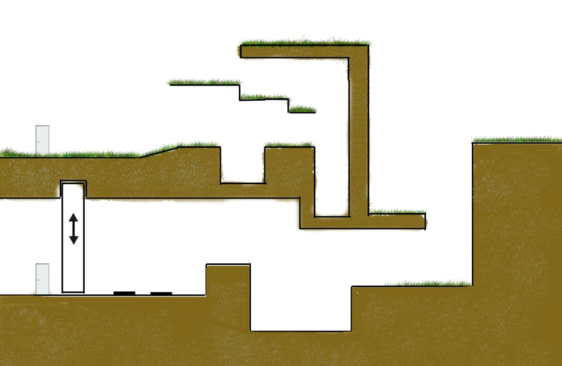

End

Start

Two Pressure plates to raise pillar, they must both be pressed at the same time

# Game Characters

## Overview

The main character will be able to switch between two characters throughout the game; Parker and Holt. The player can switch between either character at any point.

Both Characters

Each character does not have a health bar but a trauma indicator, when the character experiences too much damage at once the character dies.

Parker

Parker is a fast moving light weight character. He can jump much high and farther than Holt. He can:

* Jump off walls
* Grab onto ledges

**Holt**

Holt is a slower moving character. Holt can create objects:

* Boxes
* Planks
* Gravity Vector

## Enemies and Monsters

There are no enemies.

# User Interface

## Overview

There also is a trauma indicator that flashes on the screen when the character is hurt. The trauma indicator tints the screen edges red and intensifies as the damage accumulates. There is also a basic item count for both characters.

## Menu

The menu system will be setup such that each item in the menu is actually a door for the character to go through. When the character goes through the door and the next set of menus is complicated enough text appears instead of more doors.

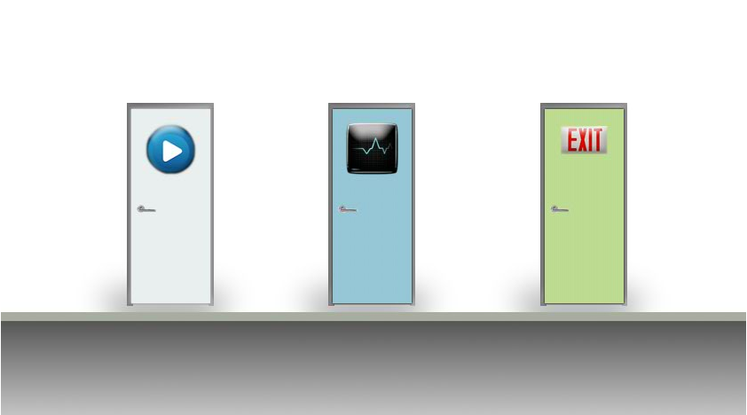

Menu example

### Main Menu

* Continue Game
* Load Saved Game
* Settings
* Exit Game

### In Game Menu

* Resume Game
* Load Game
* Save Game
* Settings Menu
* Exit to Main Menu

### Settings Menu

* Music Volume Slider
* Sound Effects Volume Slider
* Key binding listings
  + Select a list item and press a key to remap it
* HUD position
  + Bottom or top

### Load Game Profile Menu

* List of save files
* Load button
* Delete save button
* Back button

### Save Game

* List of save files
* Save button
* New Save File Button
* Delete save button
* Back button

## Mouse Interaction

The mouse is used to control the placement and creation of Holt’s various creatable objects.

**Weapons and Items**

There are no real weapons in this game but the characters do have items they use to help solve puzzles and move around levels.

See appendix for character items.

# Musical Scores and Sound Effects (No Changes Yet)

## Overview

## Sound Design

# Single-Player Game

## Overview

The point of the game is to escape the fractured reality by completing the levels’ puzzles and collecting special objects. In each level the player will collect special objects that will let them get to more stages in the Lobby. In levels there are special “events” that change the Lobby in some meaningful way, furthering the game.

You play as both characters but only use one character at a time. You can switch between either character at any time.

## Story

### Introduction

The story begins with Holt working in his private lab as he has for the last few months. He has been working on his new idea of a device that can shift matter to a parallel universe. Tonight is the night that he will finally test the device.

Meanwhile, Parker has entered a free running (parkour) race to traverse the city building tops as fast as possible. Since free running is illegal in the city the race must happen at night.

Under some sort of weird coincidence just as Holt is starting his new device Parker has just landed on top of Holt’s roof. A blinding light shines out of a skylight distracting Parker and he falls into the skylight. The light was from Holt activating the device. Parker just happens to fall on Holt when he starts to shift universes.

Holt wakes up in a new universe and looks around to see no one else there. He is very confused as he thought someone had just fallen on him. He tries to activate the device again to get back home. A bright light appears but Holt does not move. He hears a loud thud and an “Ow” come from behind him. Parker has just appeared out of nowhere.

They talk for a bit and Holt explains what just happened to the both of them. He tries the device again and Parker disappears again. He activates it another time and Parker appears once more. This time Holt makes a few changes to the devices parameters and tries one more time. Holt disappears and Parker instantaneously takes the exact same position Holt was in, and is now holding the device. Parker hits some buttons until another light appears and now Holt is exactly where Parker was standing.

They both realize that they’re missing things that they had on them when they shifted universes. Holt notices that the bag he had on him is now 30 feet away. Suddenly it clicks. The device has a fail-safe that doesn’t allow you to shift unless you have the same matter as you had when you first shifted. This was so Holt didn’t somehow interfere with another universe by leaving matter from his universe there.

Holt tells Parker that they must collect everything that was on them when they shifted. They go off into this universe looking for the things they lost.

**First Level Plot**

Parker and Holt have to collect all the items they see in the level that are theirs. As a way to let the player know what the items are, they glow and sparkle. There are several obstacles and puzzles that prevent them from easily obtaining the items.

## Hours of Gameplay

There is no real good way to estimate this without play testing levels. Levels will have an average time for completion attached to them. As for the entire games hours of play, it will be based upon how good the player is at solving problems. The total of levels and their average play times will be the hours of game play.

## Victory Conditions

The player does not win a level but accomplishes goals in each level that affect the Lobby level. There are different goals per level which can affect the Lobby in different ways. Some goals will be obtaining a new item.

## Losing Conditions

The player does not lose but experiences too much trauma and “dies” and must return to the beginning of a level or to a continue point. When the character dies they lose all items that have not been saved at a checkpoint.

## Saving and Loading

You cannot save at just any point in the game, the game automatically saves at any continue point or when you leave a level. There will be several profiles for the overall game so you can have different people playing on the same computer.

# Character Rendering

## Overview

Characters are 3D models.

## Character Animations

### Holt

Holt has 13 animations.

* Idle (maybe several)
* Walk
* Run
* Slide stop
* Jump
* Falling
* Landing from fall
* Landing from jump
* Death
  + Falling to death ( splatter )
  + Hit by thing death ( Something hit him hard enough to make him fly )
* Pushing object (an object roughly his size, so using his whole body)
* Poking buttons animation on the device
* Open and walk through door

### Parker

Parker has a total of 23 animations.

* Idle (maybe several)
* Walk
* Run
* Slide stop
* Jumps
  + Wall Jump
  + Ledge Jump
  + Running Jump (regular jump)
  + Straight up jump (to grab a ledge above him)
* Ledge
  + Grabbing the ledge
  + Holding the ledge
  + Climb over the ledge
* Falling
* Landing from fall
* Landing from jump
* Grappling Hook
  + Fire grappling hook
  + Swing on grappling hook while holding it
  + Jump off grappling hook
  + Let go of grappling hook (fall from it)
* Death
  + Falling to death ( splatter )
  + Hit by thing death ( Something hit him hard enough to make him fly )
* Pushing object (an object roughly his size, so using his whole body)
* Poking buttons animation on the device
* Open and walk through door

# Editing the World

## Overview

Levels are stored in XML files and loaded upon entering the level.

## World Editor

Currently there is no editing tool designed for this game. Level creation and editing is done through creating and altering XML files directly

# Appendix

# Objects Appendix (To Be Expanded)

## ****Holt’s Items****

* Planks
  + Planks are fairly thin and are of a set length
  + Planks are created by drawing a line with the mouse
* Boxes
  + Boxes have mass and friction and can be stacked
  + Boxes are created by clicking and scrolling the mouse wheel to choose its size.
* Gravity Distortion Device
  + This has a circular area of effect that changes the direction of gravity inside the area
  + Once the device is deployed you right click and drag in a direction and that is the direction gravity will be in or the device
  + The gravitational force vector for the device is added to the force vector of regular gravity

## ****Level Obstacles****

**These are obstacles that will be in the game.**

* Lever arm on a pivot
* Motorized levers
* Doors
* Boxes
* Fading platforms

# User Interface Appendix

# Story Appendix